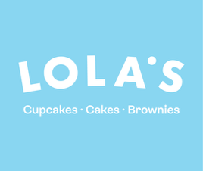
CHARITY FORM

If you work for or have a charity you’d like to raise money for then please fill in the form below so that we can help make your event extra special!
Name of Charity:

UK Charity registration number:

Web address:

Main contact for the event:

Telephone number:
Email address the account will be under:

Date of Event:

Date of Delivery/Collection:

Tell us about your charity (max. 100 words to be used on our website)

What is your role at the charity?

How are you going to use the cupcakes to raise money?

When/where is the event taking place? (if appropriate)

What was the last event you ran?

How many cupcakes would you like to request and in which flavours? (min of 36, max of 102 and ordered in multiples of 6)

Any additional Notes

Is the order being collected from store? Yes No

If yes, please specify which store:
HOW TO MAKE YOUR ORDER:

You can choose from the following cupcakes from the Classic Range:
Vanilla
Chocolate
Lemon
Mango & Passionfruit
Red Velvet
Cookies & Cream
Carrot
Blueberry
Tiramisu
Salted Caramel
Blackforest
Hazelnut
Chocolate & Raspberry
Unicorn Vanilla
Unicorn Chocolate

Vegan Red Velvet
Vegan Gluten Free Fudge
Vegan Caramel Biscuit
Vegan Raspberry & Passionfruit
Vegan Chocolate Brownie Cupcake
Vegan Gluten Free Lemon Berry

Gluten Free Red Velvet
Gluten Free Raspberry and Chocolate
Gluten Free Rainbow Vanilla
Gluten Free Cookies and Cream
Gluten Free Carrot
Gluten Free Black Forest
Gluten Free Chocolate Heaven
Gluten Free Blueberry
Gluten Free Salted Caramel
Gluten Free Tiramisu

Please note the Harry Potter and Photo cupcakes are excluded from the Charity Scheme and not available to order.

Once you’ve decided which cupcakes you’d like, sent us this completed form and your charity letter please make an account on our website before calling us up to place your order.

