Pet Tech Australia
2 in 1 Citronella Spray Trainer
Operation Guide
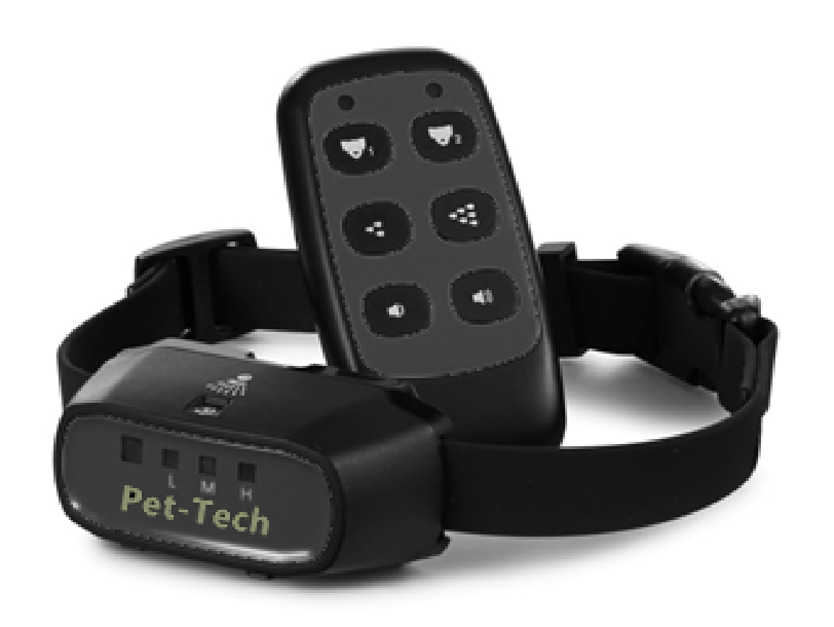

Remote Spray Trainer Operation Guide
Thank you for choosing the Pet-Tech 2 in 1 Remote Spray Trainer. Our mission is to offer the best electronic training solutions for your dogs. Please feel free to contact us if you have any problems.

Please read the complete operation guide carefully before starting to train your dog including the FAQ.
IMPORTANT SAFETY INFORMATION

Not for Aggressive Dogs. Do not use this product if your dog is aggressive, or if your dog is prone to aggressive behavior. Aggressive dogs can cause severe injury to their owners and others. If you are unsure if this product is appropriate for your dog, please consult your veterinarian or certified trainer.

CAUTION Please read and follow the instructions in the manual. Proper fit of the collar under the dog’s neck is important. A collar worn for too long or made too tight on the pet’s neck may cause skin damage. Ranging from redness to pressure ulcers
- Avoid leaving the collar on the dog for more than 8 hours out of every 24 hours and try to reposition the collar on your dog’s neck every 1 to 2 hours if possible.
- Check the fit of the collar to prevent excessive pressure.
- Examine the contact area daily for signs of a rash or a sore. Brushing the coat daily may help.
- If a rash or sore is found, discontinue use of the collar until the skin has healed.
Do not expose the device to freezing temperatures -32°F or 0°C or to conditions warmer than 113°F or 45°C. Do not leave the unit in direct sunlight. Never leave the unit in a car where the device can heat up to high temperatures 113°For 45°C.
AEROSOLS:
1.Keep out of reach of children.
2.Contents of the refill can and the spray collar are under pressure.
3. Use only in a well ventilated area. Use only as directed.
4. May explode if heated, do not heat. Do not expose to temperatures over 113°F or 45°C.
5. Do not burn. Do not dispose of in fire even when empty.
6. Keep out of direct sunlight.
7.Do not leave the aerosol can in a vehicle where temperature could exceed 113°F or 45°C.
8.Store in a cool location. Keep away from sparks or flame. Do not smoke while refilling.
9. Do not puncture. Contact of liquid propellant with skin may cause frostbite.
10. Do not ingest. In case of accident, seek medical care. If swallowed, call a poison control center immediately.
The Remote Spray Trainer is not a toy. Keep it away from the reach of children. Use it only for its pet training purpose.

These steps will help keep your pet safe and comfortable.

Training sessions which are shorter and more positive (10-15 minutes) are often the most effective.

Do not use the collar on a dog that is under 6 months old.

Improper or inappropriate use of a training collar system can be harmful. Please use this product correctly and pay attention when training your dog.

Table of Contents
Components…………………………………………....6
How the system works…………………………............6
Main Features………………………………………….7
Transmitter……………………………………………..9
Receive Collar………………………………………...11
Charge the Receive collar…………………………….12
Insert the Transmitter battery……………………........13
Match a Receive Collar………..………….…………...14
Training Guide……………………………………..…..15
General Training Tips.……………………………........16
How Dogs Learn……………………..……………..….18
Remote control mode & Auto anti bark mode………....19
How to work with Auto anti bark………………......…..19
Adjust the Sensitivity Level………………..…………..20
Frequently Asked Questions…………………………...20
Troubleshooting Guide…………………………………23
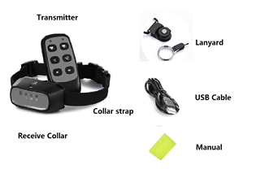
Components

How the System Works
The 2 in 1 Remote spray collar has been proven safe, comfortable, and effective for all pets over 6 months old. This system assists you in controlling your pet without a leash at a distance. At the push of a button, the remote transmitter sends a signal, activating the receive collar and emitting safety spray or warning beep.

Also, The 2 in 1 Remote Spray Trainer has an anti bark function. If you don’t use remote control in the first 60 seconds after turning on the collar , the receiver collar will enter anti bark mode automatically. The microphone will be activated by dog’s bark then the receive collar will emit warning beep and safety spray to help stop barking.
Important: The actual distance of remote trainer is dependent on the way you hold the remote transmitter - the range may vary. Hold the remote transmitter in a horizontal position away from your body to achieve optimum range. Terrain, weather, vegetation, vehicles, buildings, transmission from other radio devices, and other factors will affect the range of your remote trainer.
Main Features
- -Combines remote training function with auto anti bark function.
- - Range up to 150 meters in open field with line of sight.
- -Auto anti bark function.
- -Suitable for all dogs (6 months and 5kg
- - Train up to 2 dogs with the same transmitter.
- - Long and Short spray.
- - High and Low warning beep.
- - Select your dog with dog selection button.
- - Rechargeable 3.7V Li-ion battery for receiver.
- - 2 PCS of 3AAA battery for remote controller.
- -Soft Nylon Collar Strap.
- - LED low power indication. Red light will flash 1 time each
- second when battery level is low.
- -LED low spray indication. Red light will flash 1 time every
- five seconds when the spray is low.

Transmitter
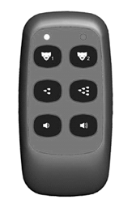
Red Led
Low Beep

High Beep
Short Spray
Green Led
Long Spray
Dog 1
Dog 2
Red Led: Indicates the first dog and low battery. Press the Dog 1 button or Spray button or beep button once, the Red led light will flash one time after choosing the first dog. When battery is low, the Red led will flash 1 time every second.
Green Led: Indicates the second dog. Press the Dog 2 button or Spray button or beep button once, the green led light will flash one time after choosing the second dog.
Dog 1 button: Select the first dog and match the first dog collar; Press this button to control the first dog.
Dog 2 button: Select the second dog and match the second collar ; Press this button to control the second dog.
Short Spray button: Spray shot. Press once - receiver collar emit 1 short spray.
Long Spray button: Spray long. Press once- receiver collar emit 1 long spray.
Low Beep button: Warning beep. Press once- receive collar emit 1 low warning beep.
High Beep button: Warning beep , Press once - receive collar emit 1 high warning beep.

Receive Collar
Spray Nozzle
Blue Led
Indicates the sensitivity level High, Middle and Low.
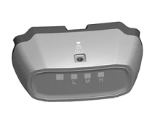
LED Light
Indicates the working status, low battery, low spray, charging status.

Microphone
Dog bark sensor. Picks up the dog’s bark.

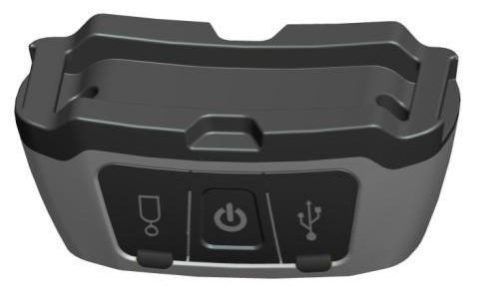
Mini USB
Refill Port
On/Off button
Press and hold for 1 second to turn the collar on. Two confirming tones will sound and the green LED light will flash 1 time every 5 seconds. Press and hold for 1 second to turn the collar off. One long tone will sound and the green LED light will stop flashing and turn off.

Function and Response Table
Function | LED Light Response
Unit is on | Green light flashes once every 5 seconds
Low battery | Red light flashes once every second
Low spray | Red light flash once every 5 seconds
Charging | Red light is on
Full charge | Green light is on

Charge the Receive collar
The receiver can be charged rapidly in about 2 hours. Though 3-4 hours charging is better for the battery life.
The receive collar can be charged by connecting USB cable and 5V DC power supply, such as cell phone adapter, laptop, or computer.
Do not charge battery in hot areas. keep far away from fire.
The red LED light is on when charging.
The green LED light will turn on and the red LED light will turn off when the receive collar is full charged.
The receiver’s red LED light will flash once per second when the battery is low power. Please recharge the battery.
Insert the Transmitter battery
1. Hold the Remote Transmitter face down. Gently push on the lower door, slide down and remove the battery cover.
2. Insert 2 pieces of 1.5-Volt alkaline batteries according to the correct “+” and “-“ polarity.
3. Close the battery cover.
4. Test the transmitter.
Press any one button of transmitter. The Red led or Green led will flash indicating that the batteries are inserted correctly.
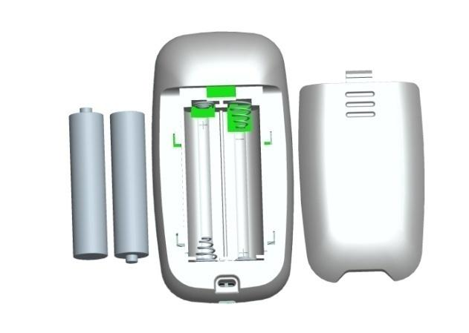

Pair a Receiver Collar with the remote
To add a receive collar to your remote dog training system, please follow below steps. Only turn on 1 collar at a time to connect then follow below steps for the 2nd collar if required.
Step 1: Take out 1 unpaired collar. Press and hold “ON/OFF” button. After two “beep” sounds, release the button, the power of receiver should be on.
Step 2: Take out the transmitter. Press and hold on the Dog 1 button (within 10 seconds after turning on the unmatched collar) until you hear 5 “beeps” sound from the receiver then release.
If you want to pair the second dog collar, press and hold on the Dog 2 button.
Note: You should press and hold on Dog 1 button or Dog 2 buttons within 10 seconds after turn on the unmatched receive collar.
Step 3: Test matched Receiver
press Dog1 button, if you can see the red led flash once on the paired receive collar then congratulations, you have paired the first receive collar.
You can also press Beep button 1time to test, you will hear 1 sound warning beep from the matched receive collar if paired correctly.

Remote control mode & Auto anti bark mode

Auto anti bark mode: The receiver collar will enter auto anti
bark mode automatically 1 minute after turning on if the
receiver doesn’t receive any signals from the remote.
(within the first 1minute)
Remote control mode: If the receiver collar gets a signal from the transmitter within 1 minute after being turned on the receiver will be in remote training mode. The receive collar will stay in remote control mode until you turn it off.

How Auto anti bark mod works
1) The collar will issue one beep audio warning when the device detects the first bark.
2) The collar will begin to emit a spray shot automatically if the collar continues to detect subsequent barks.
3) The collar will return to the original status if it doesn’t detect mor barking within in 120 seconds. Then it will start to issue the warning beep again as per step 1 above.

Adjust the Sensitivity Level
1) The receive collar has 3 levels of sensitivity: Low, medium and High.
2) You can adjust the sensitivity level according to the dog type and loudness of your dog’s barking.
3) You can press the On/Off to adjust the sensitivity level when the receive collar is power on.
Press On/Off button once and the sensitivity level will change between these 3 levels (indicated by the blue light)

TRAINING GUIDEstand
Fitting Collar on the Dog
Make sure your dog is standing then place the collar strap on the middle of the dog’s neck. The receiver should be on the underside of his/her neck, with the Spray Nozzle towards the dog’s nose.
The Receiver Collar should fit snugly, yet loose enough to allow one finger to fit under the strap.

Ensure a Proper Spray Pattern
For the Receive Collar to perform properly, the nozzle must be positioned correctly and there must be a clear path from the Spray Nozzle to your dog’s snout.
1. Make sure the Spray Nozzle is angled out and pointing up towards the dog's snout.
2. For long-haired dogs, it may be necessary to trim the neck
hairs along the path of the spray. It is important that the spray
reach the dog’s snout to be effective.
3. For optimal performance, the Receive Collar should be refilled
before each use.
General Training Tips
1. Make training sessions short and positive (each session between 10-15 minutes)
2. Train one dog at a time.
3. During the first initial training session, keep the dog in a familiar outdoor environment.
4. Use a long leash fastened to a non-metallic collar to help the dog's learning.
5. Be consistent. Give your dog a tone and/or spray with each misbehaviour.
6. Teach the dog a command first before reinforcing the command with the remote transmitter.
7. Issue one obedience command at a time. Do not use the training system for commands that the dog has not learnt.
8. Do not over correct your dog. Use as few sprays as possible to train your dog.
9. During training, look for all the positive changes in the dog's behavior and remember to reinforce them promptly with ample praise and reward.
10. If your dog has a timid reaction to the tone or spray (especially the first couple of times), do not be alarmed. Redirect his attention to a simple and appropriate behaviour (i.e. a known command such as “sit”).
11. Please keep in mind, that you should keep training sessions short and end every session on a high note. Stop training and play with the dog as soon as the dog has accomplished a new level of proficiency.
12. Never use the 2 in 1 Remote Spray Trainer to correct or eliminate any form of aggressive behaviour. If your dog exhibits such behaviour, contact a professional trainer. Aggression in dogs is the result of many factors- it may be a learned behaviour or it may be brought on as a result of fear. Another factor contributing to aggression in dogs is social dominance. Every dog is different.

HOW DOGS LEARN
Here are some basic guidelines that cover all your remote trainer work on obedience commands.

Follow a step-by-step introduction process on each command. Don’t assume that your dog will understand a remote trainer correction in connection with a command. The stimulus can confuse them initially, even if they knows the command.

Don’t introduce remote training around distractions.
Keep things simple for your dog in their first sessions. They won’t learn well when there’s too much going on.

Frequently Asked Questions
Is the spray safe for my dog? Though the spray is unpleasant, it is harmless to your dog.
Is the collar rainproof? Yes (weather proof, not waterproof)
How old should my dog be before I use this device? It is recommended that your dog be 6 months old to use a training collar. Your dog should have learned the basic commands such as “sit” or “stay”.

The collar is too long, is it ok to cut off the excess collar?
Yes – seal the end with glue or a lighter to stop it from fraying.
Can I use this on my aggressive dog? We do not recommend any of our products to be used on aggressive dogs. In this situation please contact your local veterinarian or professional to trainer to determine if your dog might be aggressive.
Will I get exactly the 500 feet range as advertised? Testing for the 500 feet range is performed in perfect conditions. The range you get will vary according to terrain, weather, vegetation, as well as transmission from other radio devices. For best results make sure the collar has the light closest to the dogs nose and you hold the remote horizontally and away from your body.
Does the spray need to hit my dog’s nose?
No. The spray is very fine and simply creates a mist in the region of the snout.

Will this work automatically when my dog barks?
Yes, you need to confirm the receive collar is Auto anti bark mode.

How many dogs can I set up on this system?2. Please purchase extra collars if needed.
When will I know to refill the spray? We suggest that full refill the spray before each training session. When the red Led of the receive collars flash once per 5 seconds, please refill the spray.
Can I refill spray while the dog wears the receive collar ? No. Please take off from your pet, turn off the receive collar, then refill the spray.

Troubleshooting Guide

Problem #1: No spray or beep when a transmitter button is pressed.
The receiver has not been activated. The receiver must be turned on otherwise it won’t work at all.
The receiver has not been matched to your transmitter. Follow the instructions to match.

Problem#2: The beeper of receiver doesn’t make any sound when the receiver is turned on.
Press dog selection button to choose correct dog ID before pressing
The batteries are dead. Recharge as needed.
Problem#3: The receiver light changes color to indicate low battery very quickly.
The unit has been left turned on in between training session. Make sure the receiver is turned off after use.
You are training in very cold weather.
Problem#4: The remote trainer doesn’t have range or the range is significantly reduced.
Try a more open space with less nearby structures.
The receiver is on backwards. For best range, position the receiver so that the light face toward the dog’s nose.
Radio interference. Wait a short while then try again, or move to another area.
Problem#6: The receiver can’t receive any signal or cannot work at all.
Check the receiver on/off button, make sure the receiver is turned on.
Check the transmitter, if it has a low battery, replace battery first.
The charger is broken, please try another charger.
Cancel the receiver match, then re-match it with the transmitter.


