Ergonomic Bench Assembly & Securing Procedure
Technical Installation Manual — Calf Panel, Seat Panel Support & Rear Retention Block
Fasteners: M6 x 30 mm wood screws, Phillips head. Driver clutch stage 2–3 (approx. 1.5–2.0 N·m) — do not exceed 2.5 N·m. Disconnect any wiring near the seat panel support before starting.

Step 1: Fix the Calf Panel to the Seat Panel Support
- Seat the calf panel's lower edge fully into the seat panel support frame, flush with no gap.
- Align the cross brace's pilot hole over the calf panel hole (see Figure 1).
- Drive one screw through the brace into the panel until flush — do not countersink below the surface.
- Check rigidity: no lateral movement or creak when the panel is pushed.
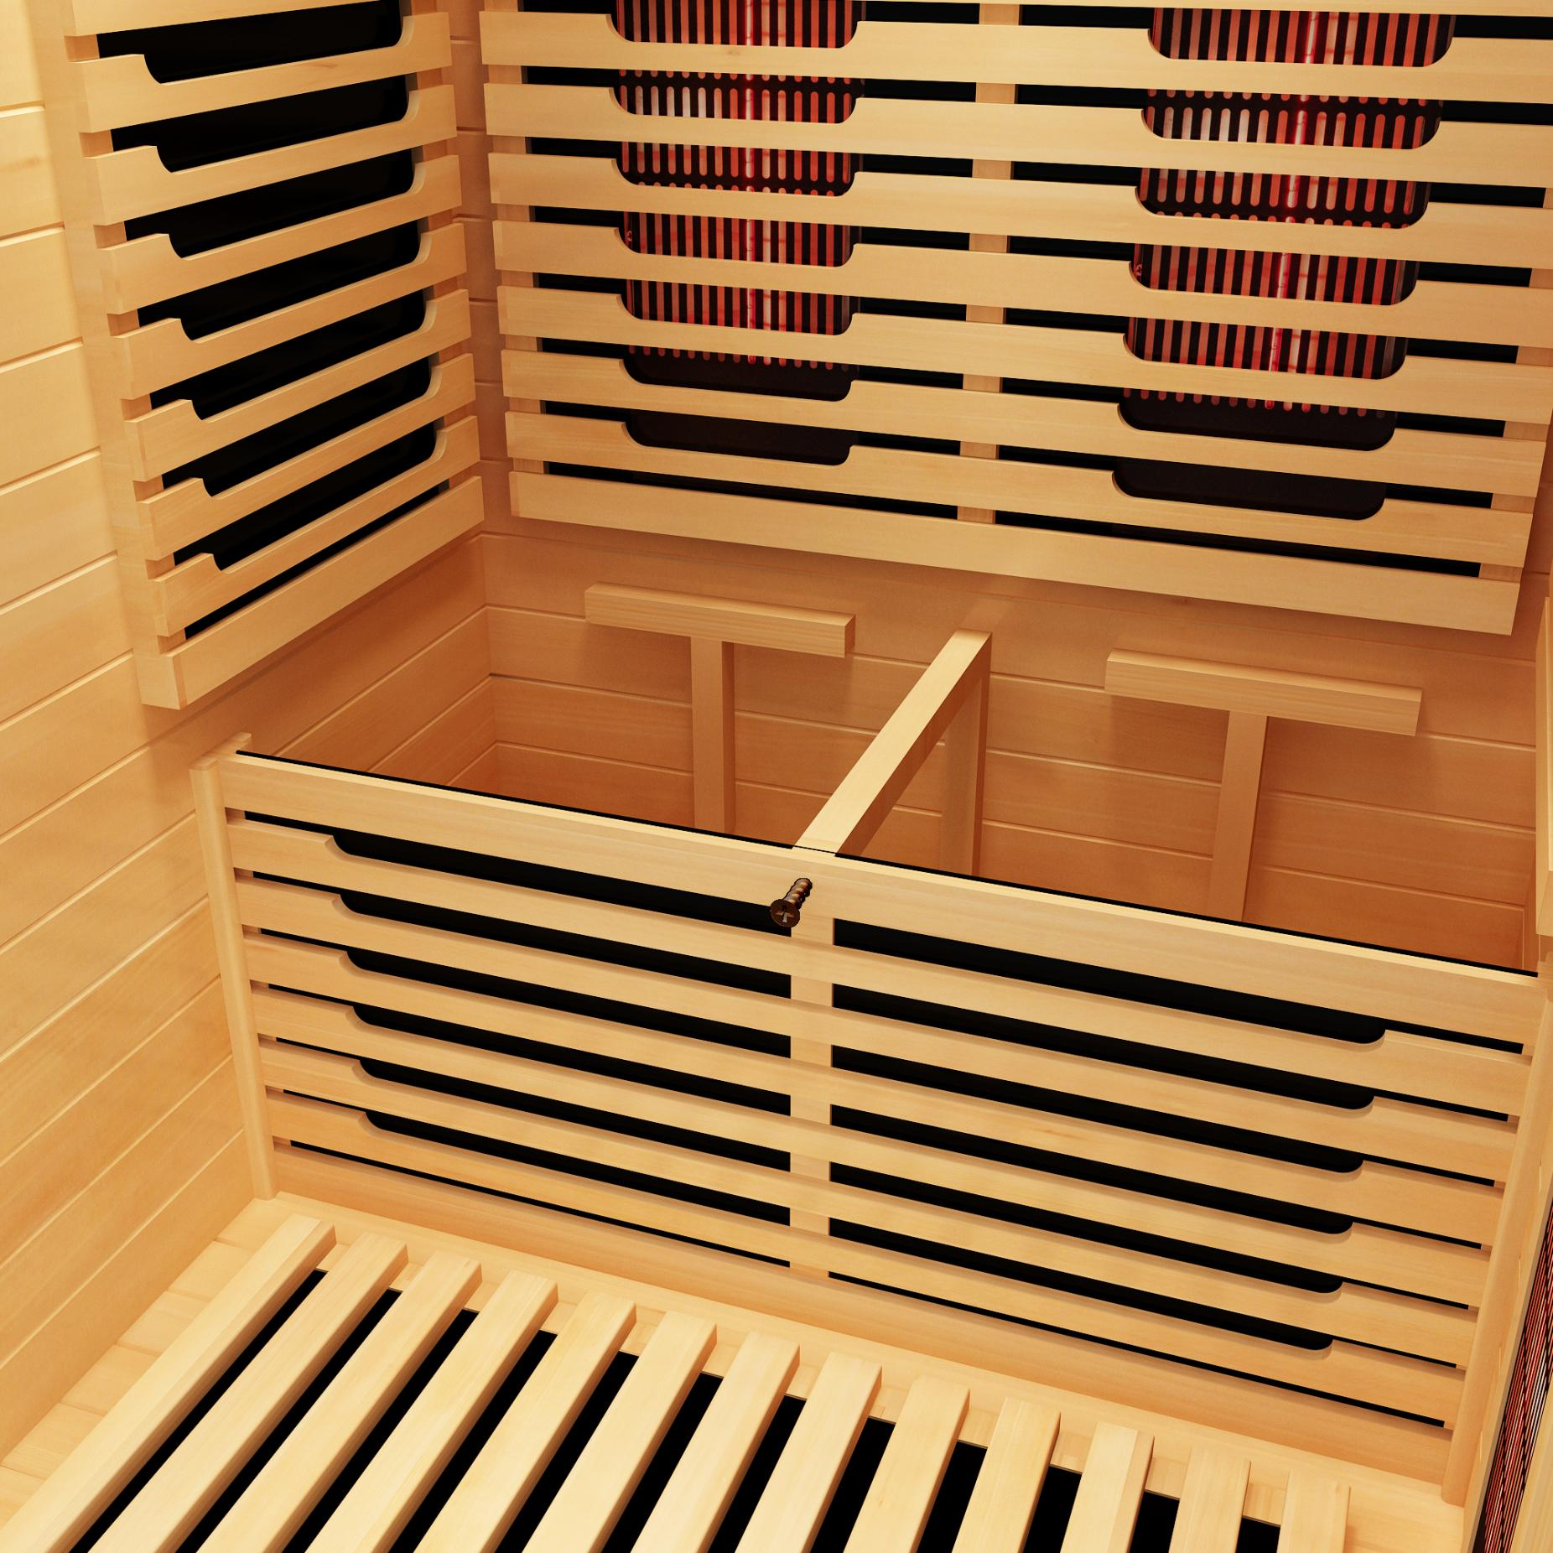
Figure 1. Calf panel secured to the seat panel support.

Step 2: Fix the Wooden Block to the Rear of the Seat Panel
- With the seat panel face-down, position the block flush against the rear edge, matching its placement in Figure 2. The block already has pilot holes drilled through it — the seat panel does not.
- Holding the block in place, use its pilot holes as a guide to mark the drilling points on the seat panel, then drill a matching 3 mm pilot hole at each mark.
- Hand-start both screws through the block into the pilot holes before driving either fully, keeping the block flush and square against the edge.
- Drive both screws evenly, alternating to keep the block square. Do not over-tighten — excess torque can split the grain.
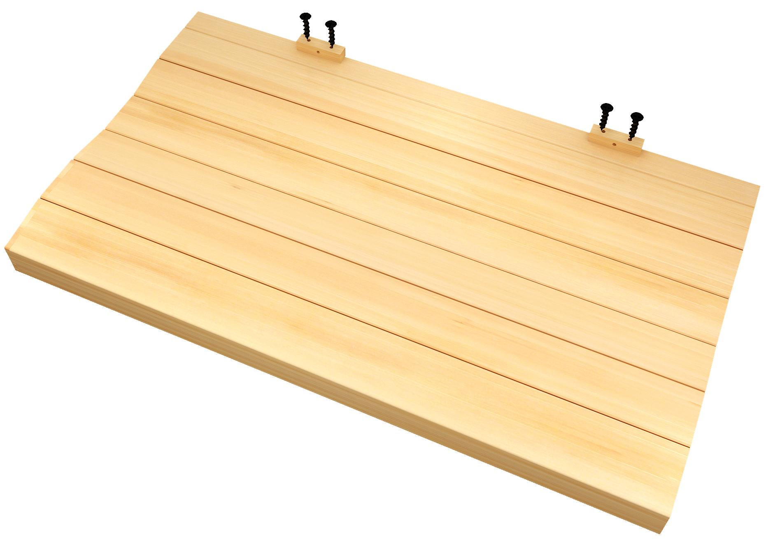
Figure 2. Block with pilot holes — use it to mark drill points on the panel.

Step 3: Install the Seat and Anchor to the Rear Wall
- Lower the seat assembly into the enclosure, guiding the supports into place.
- Slide it rearward until the wooden block contacts the rear wall; confirm the seat sits level.
- Drive one screw at each of the two marked points where the block meets the rear wall (Figure 3).
- Recheck Step 1 and 2 joints, then load-test: press firmly at front, center, and rear — no deflection or creak.
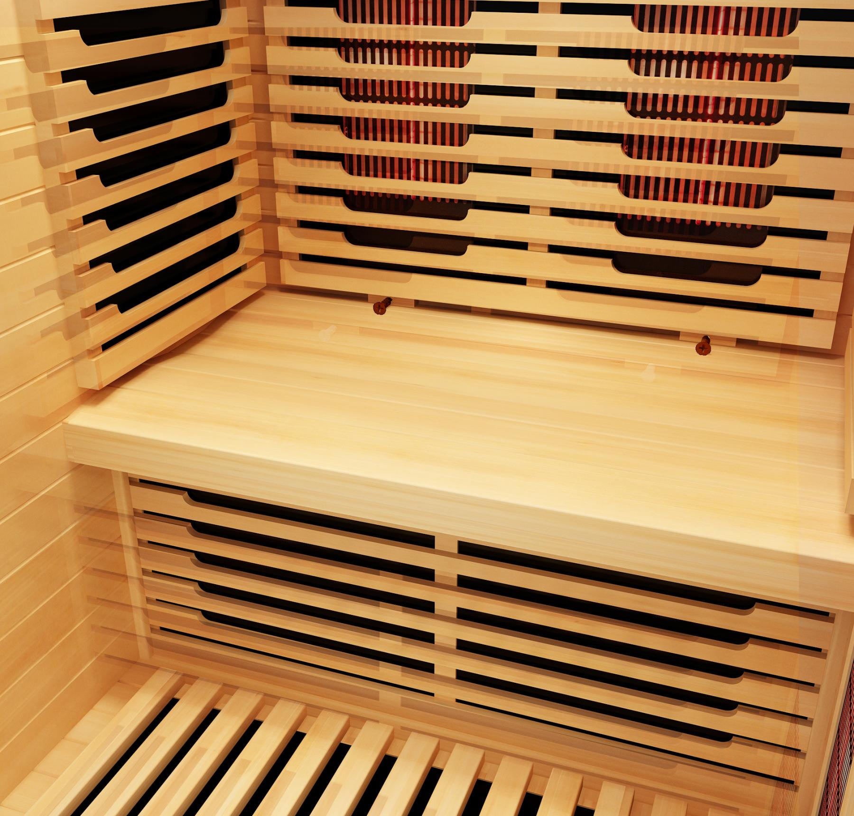
Figure 3. Completed installation — block fastened to the rear wall.
CAUTION: Do not sit on the bench until all fastening points above are installed and the load test has passed.

